Jerry Olds

1001533643

CSE-4321-002

3/28/2019

Homework 3

1.

|  |  |  |  |  |  |  |  |  |
| --- | --- | --- | --- | --- | --- | --- | --- | --- |
|  | **Rule 1** | **Rule 2** | **Rule 3** | **Rule 4** | **Rule 5** | **Rule 6** | **Rule 7** | **Rule 8** |
| **Conditions** | | | | | | | | | |
| member == TRUE && primeStatus == TRUE &&  $5,000.00 <= cart <= $10,000.00 | **Y** |  |  |  |  |  |  |  |
| member == FALSE && primeStatus == TRUE &&  $5,000.00 <= cart <= $10,000.00 |  | **Y** |  |  |  |  |  |  |
| member == TRUE && primeStatus == FALSE &&  $5,000.00 <= cart <= $10,000.00 |  |  | **Y** |  |  |  |  |  |
| member == FALSE && primeStatus == FALSE &&  $5,000.00 <= cart <= $10,000.00 |  |  |  | **Y** |  |  |  |  |
| member == TRUE && primeStatus == TRUE &&  $0.00 <= cart <= $4999.99 |  |  |  |  | **Y** |  |  |  |
| member == TRUE && primeStatus == FALSE &&  $0.00 <= cart <= $4999.99 |  |  |  |  |  | **Y** |  |  |
| member == FALSE && primeStatus == TRUE &&  $0.00 <= cart <= $4999.99 |  |  |  |  |  |  | **Y** |  |
| member == FALSE && primeStatus == FALSE &&  $0.00 <= cart <= $4999.99 |  |  |  |  |  |  |  | **Y** |
| **Actions** | | | | | | | | | |
| Rate | **0.95** | **0.975** | **0.925** | **0.965** | **0.9** | **0.95** | **0.955** | **0.985** |

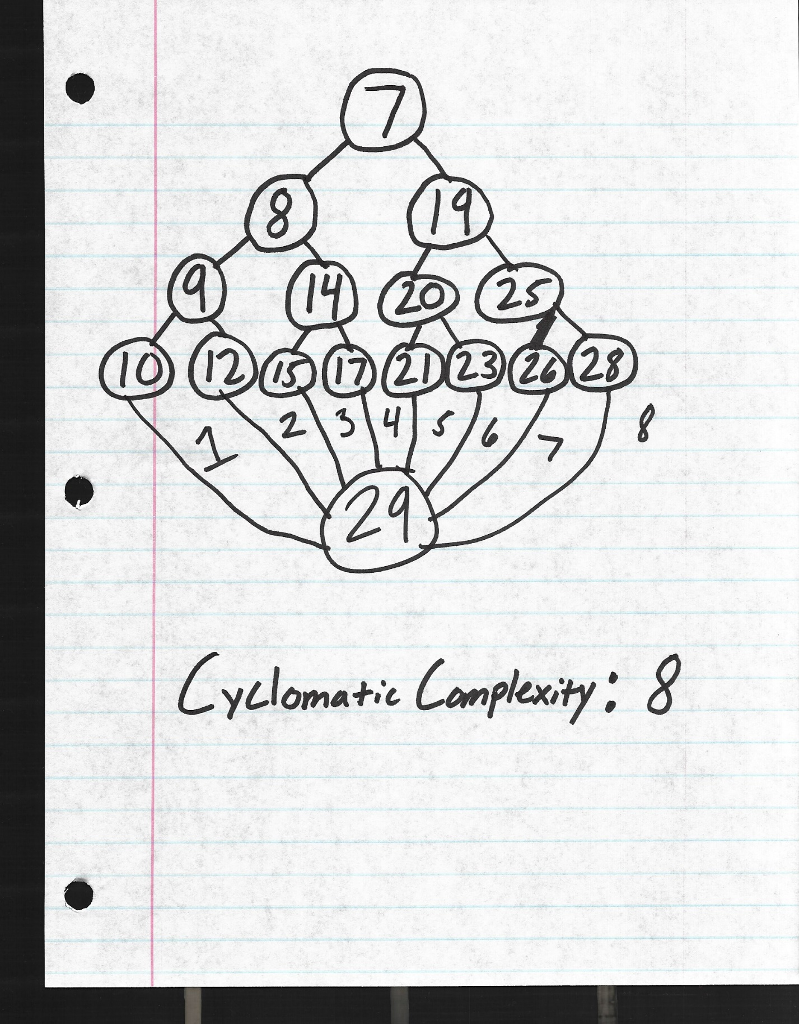

|  |  |  |  |  |  |
| --- | --- | --- | --- | --- | --- |
| **Test Case Number** | **Inputs** | | | **Exp Out** | **Comments** |
| **member** | **primeStatus** | **cart ($)** | **rate** |
| 1 | TRUE | TRUE | $5,000.00 | 0.95 | 7-8-9-10-29 |
| 2 | FALSE | TRUE | $5,000.00 | 0.975 | 7-19-20-21-29 |
| 3 | TRUE | FALSE | $5,000.00 | 0.925 | 7-8-14-15-29 |
| 4 | FALSE | FALSE | $5,000.00 | 0.965 | 7-19-25-26-29 |
| 5 | TRUE | TRUE | $4,999.99 | 0.9 | 7-8-9-12-29 |
| 6 | TRUE | FALSE | $4,999.99 | 0.95 | 7-8-14-17-29 |
| 7 | FALSE | TRUE | $4,999.99 | 0.955 | 7-19-20-23-29 |
| 8 | FALSE | FALSE | $4,999.99 | 0.985 | 7-19-25-28-29 |
| 9 | TRUE | TRUE | $0.00 | 0.9 | - |
| 10 | TRUE | TRUE | $10,000.00 | 0.95 | - |

**Full Statement and Decision coverage achieved**

**Test cases support description**

2.

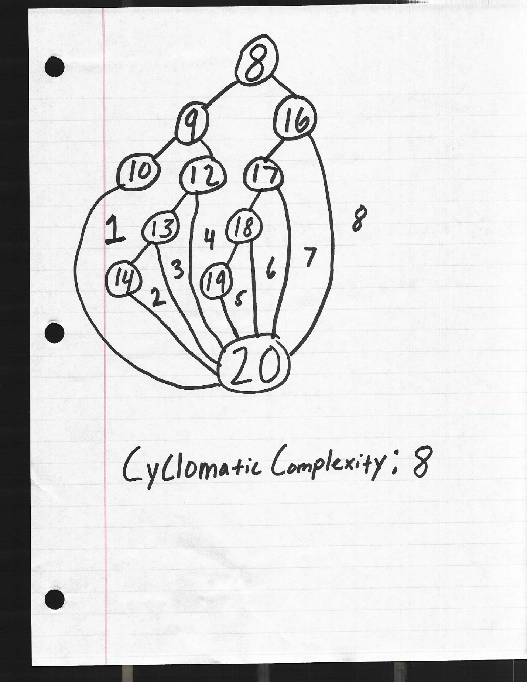

|  |  |  |  |  |  |
| --- | --- | --- | --- | --- | --- |
| **Test Case Number** | **Inputs** | | | **Exp Out** | **Comments** |
| **status** | **temp (F)** | **pressure (Hg)** | **return** |
| 1 | TRUE | 120.1 | - | TRUE | 8-9-10-20 |
| 2 | FALSE | 80.0 | 31.1 | TRUE | 8-16-17-18-19-20 |
| 3 | TRUE | 120.0 | 30.6 | TRUE | 8-9-12-13-14-20 |
| 4 | FALSE | 79.9 | - | FALSE | 8-16-20 |
| 5 | TRUE | 120.0 | 39.1 | FALSE | 8-9-12-20 |
| 6 | FALSE | 80.0 | 39.6 | FALSE | 8-16-17-20 |
| 7 | TRUE | 120.0 | 30.5 | FALSE | 8-9-12-13-20 |
| 8 | FALSE | 80.0 | 31.0 | FALSE | 8-16-17-18-20 |
| 9 | TRUE | 120.0 | 39.0 | TRUE | - |
| 10 | FALSE | 80.0 | 39.5 | TRUE | - |
| 11 | TRUE | 0.0 | 30.6 | TRUE | - |
| 12 | TRUE | 150.0 | - | TRUE | - |
| 13 | TRUE | 120.0 | 0.0 | FALSE | - |
| 14 | TRUE | 120.0 | 40.0 | FALSE | - |

a = (status = Problem2ClassStatus.NorthernHemisphere)

b = (temp > 120.0)

c = (pressure <= 39.0 && pressure > 30.5)

d = (temp >= 80.0)

e = (pressure <= 39.5 && pressure > 31.0)

if(((a && b) || c) || (d && e))  
 HPCell = true;

**Full Statement and Decision coverage achieved**

**Test cases support description**

3.

|  |  |  |  |  |  |
| --- | --- | --- | --- | --- | --- |
|  | **Rule 1** | **Rule 2** | **Rule 3** | **Rule 4** | **Rule 5** |
| **Conditions** | | | | | |
| 400.0 <= distance <= 1000.0 | **Y** |  |  |  |  |
| 95.1 <= distance <=399.9 |  | **Y** |  |  |  |
| 50.0 <= distance <= 95.0 |  |  | **Y** |  |  |
| 25.1 <= distance <= 49.9 |  |  |  | **Y** |  |
| 0.0 <= distance <= 25.0 |  |  |  |  | **Y** |
| **Actions** | | | | | |
| greenLight | **TRUE** | FALSE | FALSE | FALSE | FALSE |
| yellowLight | FALSE | **TRUE** | **TRUE** | FALSE | FALSE |
| redLight | FALSE | FALSE | FALSE | **TRUE** | **TRUE** |
| buzzer | FALSE | FALSE | **TRUE** | **TRUE** | **TRUE** |
| brakes | FALSE | FALSE | FALSE | FALSE | **TRUE** |

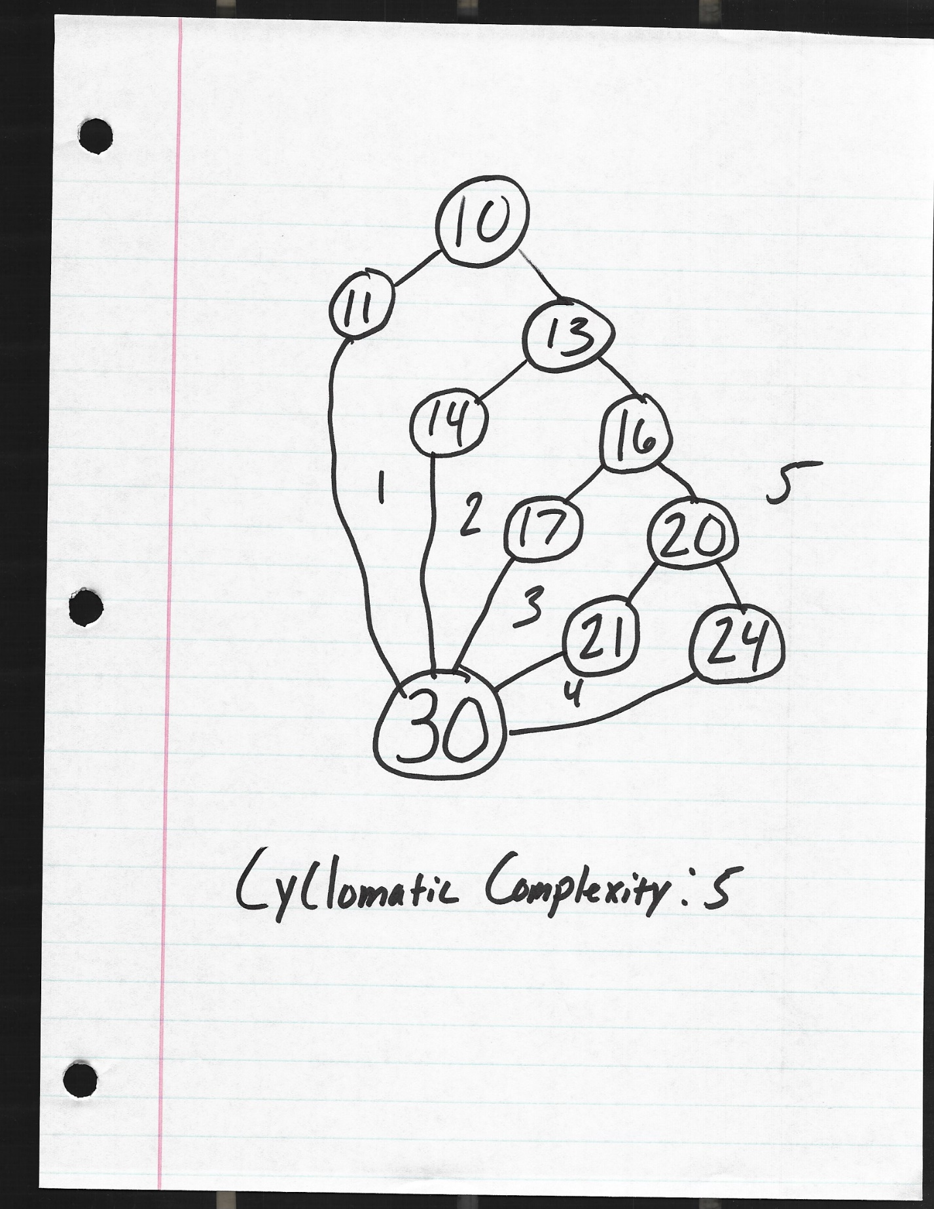

|  |  |  |  |  |  |  |  |  |  |
| --- | --- | --- | --- | --- | --- | --- | --- | --- | --- |
| **Test Case Number** | **Inputs** | | **Exp Out** | | | | | | **Comments** |
| **distance** | **count** | **greenLight** | **yellowLight** | **redLight** | **buzzer** | **brakes** | **count** |
| 1 | 400.0 | 0 | **TRUE** | FALSE | FALSE | FALSE | FALSE | 0 | 10-11 |
| 2 | 95.1 | 0 | FALSE | **TRUE** | FALSE | FALSE | FALSE | 0 | 10-13-14 |
| 3 | 50.0 | 0 | FALSE | **TRUE** | FALSE | **TRUE** | FALSE | 0 | 10-13-16-17 |
| 4 | 25.1 | 0 | FALSE | FALSE | **TRUE** | **TRUE** | FALSE | 0 | 10-13-16-20-21 |
| 5 | 25.0 | 0 | FALSE | FALSE | **TRUE** | **TRUE** | **TRUE** | 1 | 10-13-16-20-24 |
| 6 | - | 2 | FALSE | FALSE | FALSE | FALSE | FALSE | 0 | 30 |
| 7 | 399.9 | 0 | FALSE | **TRUE** | FALSE | FALSE | FALSE | 0 | - |
| 8 | 95.0 | 0 | FALSE | **TRUE** | FALSE | **TRUE** | FALSE | 0 | - |
| 9 | 49.9 | 0 | FALSE | FALSE | **TRUE** | **TRUE** | FALSE | 0 | - |
| 10 | 0.0 | 0 | FALSE | FALSE | **TRUE** | **TRUE** | **TRUE** | 1 | - |
| 11 | 1,000.0 | 0 | **TRUE** | FALSE | FALSE | FALSE | FALSE | 0 | - |
| 12 | 25.0 | 1 | FALSE | FALSE | **TRUE** | **TRUE** | **TRUE** | 2 | - |

**Statement and Decision coverage NOT achieved**

**Test cases support description**

4.

|  |  |  |  |  |  |
| --- | --- | --- | --- | --- | --- |
|  | **Rule 1** | **Rule 2** | **Rule 3** | **Rule 4** | **Rule 5** |
| **Conditions** |  |  |  |  |  |
| $2,500.00 <= cart <= $10,000.00 | **Y** |  |  |  |  |
| $1,500.01 <= cart <= $2,499.99 |  | **Y** |  |  |  |
| $750.01 <= cart <= $1,500.00 |  |  | **Y** |  |  |
| $500.00 <= cart <= $750.00 |  |  |  | **Y** |  |
| $0.00 <= cart <= $499.99 |  |  |  |  | **Y** |
| **Actions** | | | | | |
| discount | **0.2** | **0.15** | **0.125** | **0.10** | **0.0** |

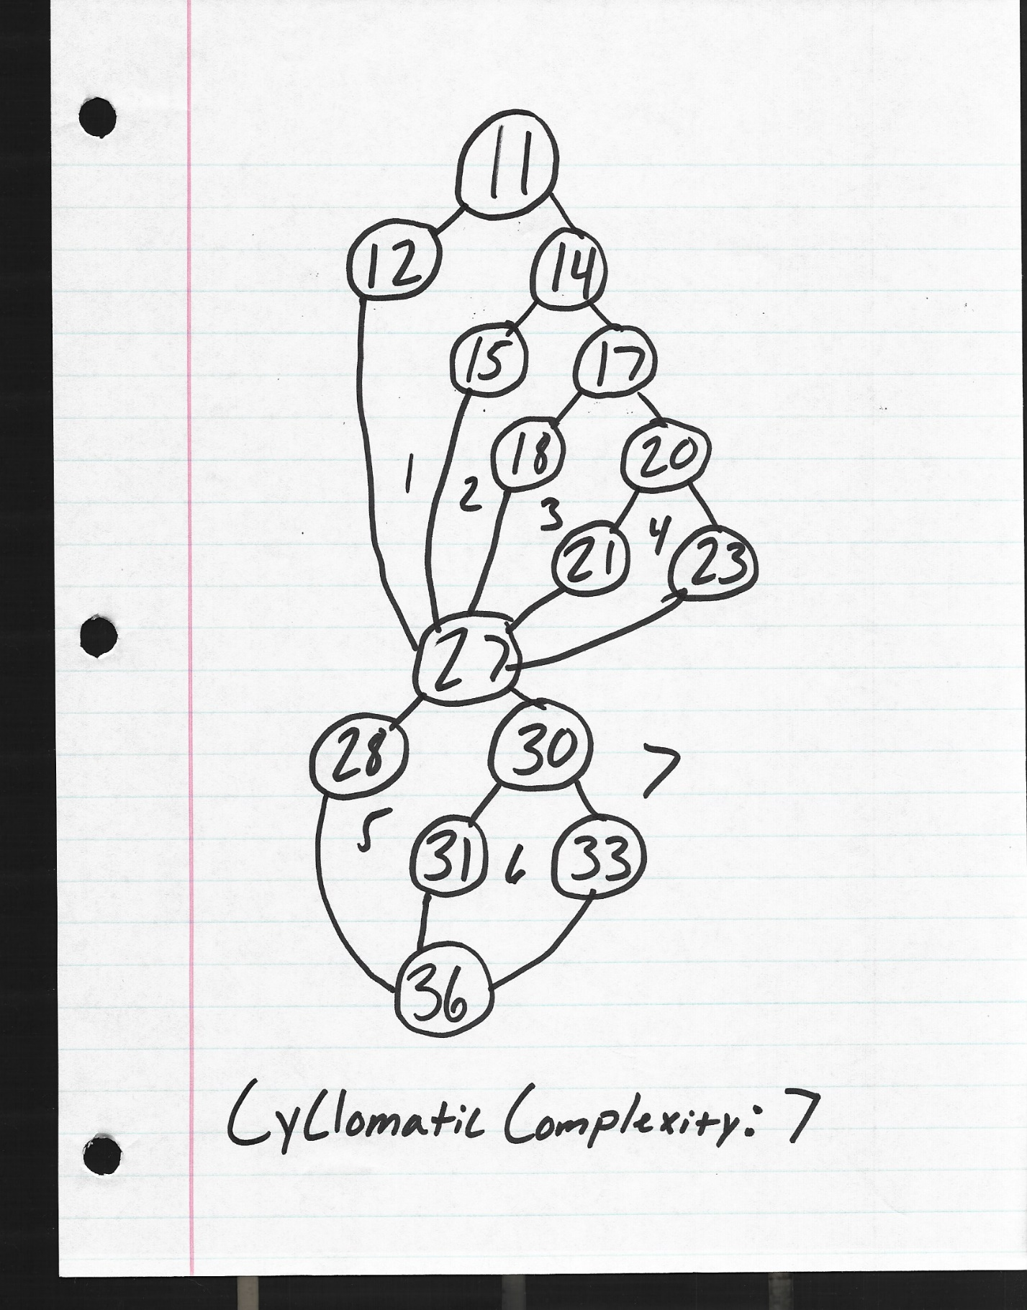

|  |  |  |  |  |
| --- | --- | --- | --- | --- |
| **Test Case Number** | **Inputs** | | **Exp Out** | **Comments** |
| **cart** | **taxRate** | **total** |
| 1 | $2,500.00 | 0.0825 | $2,165.00 | 11-12 |
| 2 | $1,500.01 | 0.0825 | $1,380.19 | 11-14-15 |
| 3 | $750.01 | 0.0825 | $710.40 | 11-14-17-18 |
| 4 | $500.00 | 0.0825 | $487.12 | 11-14-17-20-21 |
| 5 | $499.99 | 0.0825 | $487.11 | 11-14-17-20-23 |
| 6 | $2,499.99 | 0.0825 | $2,300.30 | - |
| 7 | $1,500.00 | 0.0825 | $1,420.78 | - |
| 8 | $750.00 | 0.0825 | $730.68 | - |
| 9 | $0.00 | 0.0825 | $0.00 | - |
| 10 | $10,000.00 | 0.0825 | $8,660.00 | - |

|  |  |  |  |  |  |  |  |  |
| --- | --- | --- | --- | --- | --- | --- | --- | --- |
| **Test Case Number** | **Inputs** | | | | |  | | **Comments** |
| **cart** | **firstTimeBuyer** | **goldStatus** | **bonusPoints** | **taxRate** | **total** | **memberBonus** |
| 1 | - | TRUE | - | - | - | - | TRUE | 27-28 |
| 2 | - | FALSE | TRUE | - | - | - | TRUE | 27-30-31 |
| 3 | $1,000.01 | FALSE | FALSE | 751 | 0.0825 | $947.19 | TRUE | 27-30-33 |
| 4 | $1,000.00 | FALSE | FALSE | - | 0.0825 | $947.18 | FALSE | - |
| 5 | $1,000.01 | FALSE | FALSE | 750 | 0.0825 | $947.19 | FALSE | - |
| 6 | $1,000.01 | FALSE | FALSE | 0 | 0.0825 | $947.19 | FALSE | - |
| 7 | $1,000.01 | FALSE | FALSE | 1000 | 0.0825 | $947.19 | TRUE | - |

a = (firstTimeBuyer == TRUE)

b = (goldStatus == TRUE)

c = (cart > 1,000.00)

d = (bonusPoints > 750)

if(a || b || (c && d))  
 memberBonus = true;

**Full Statement and Decision coverage achieved**

**Test cases support description**

5.

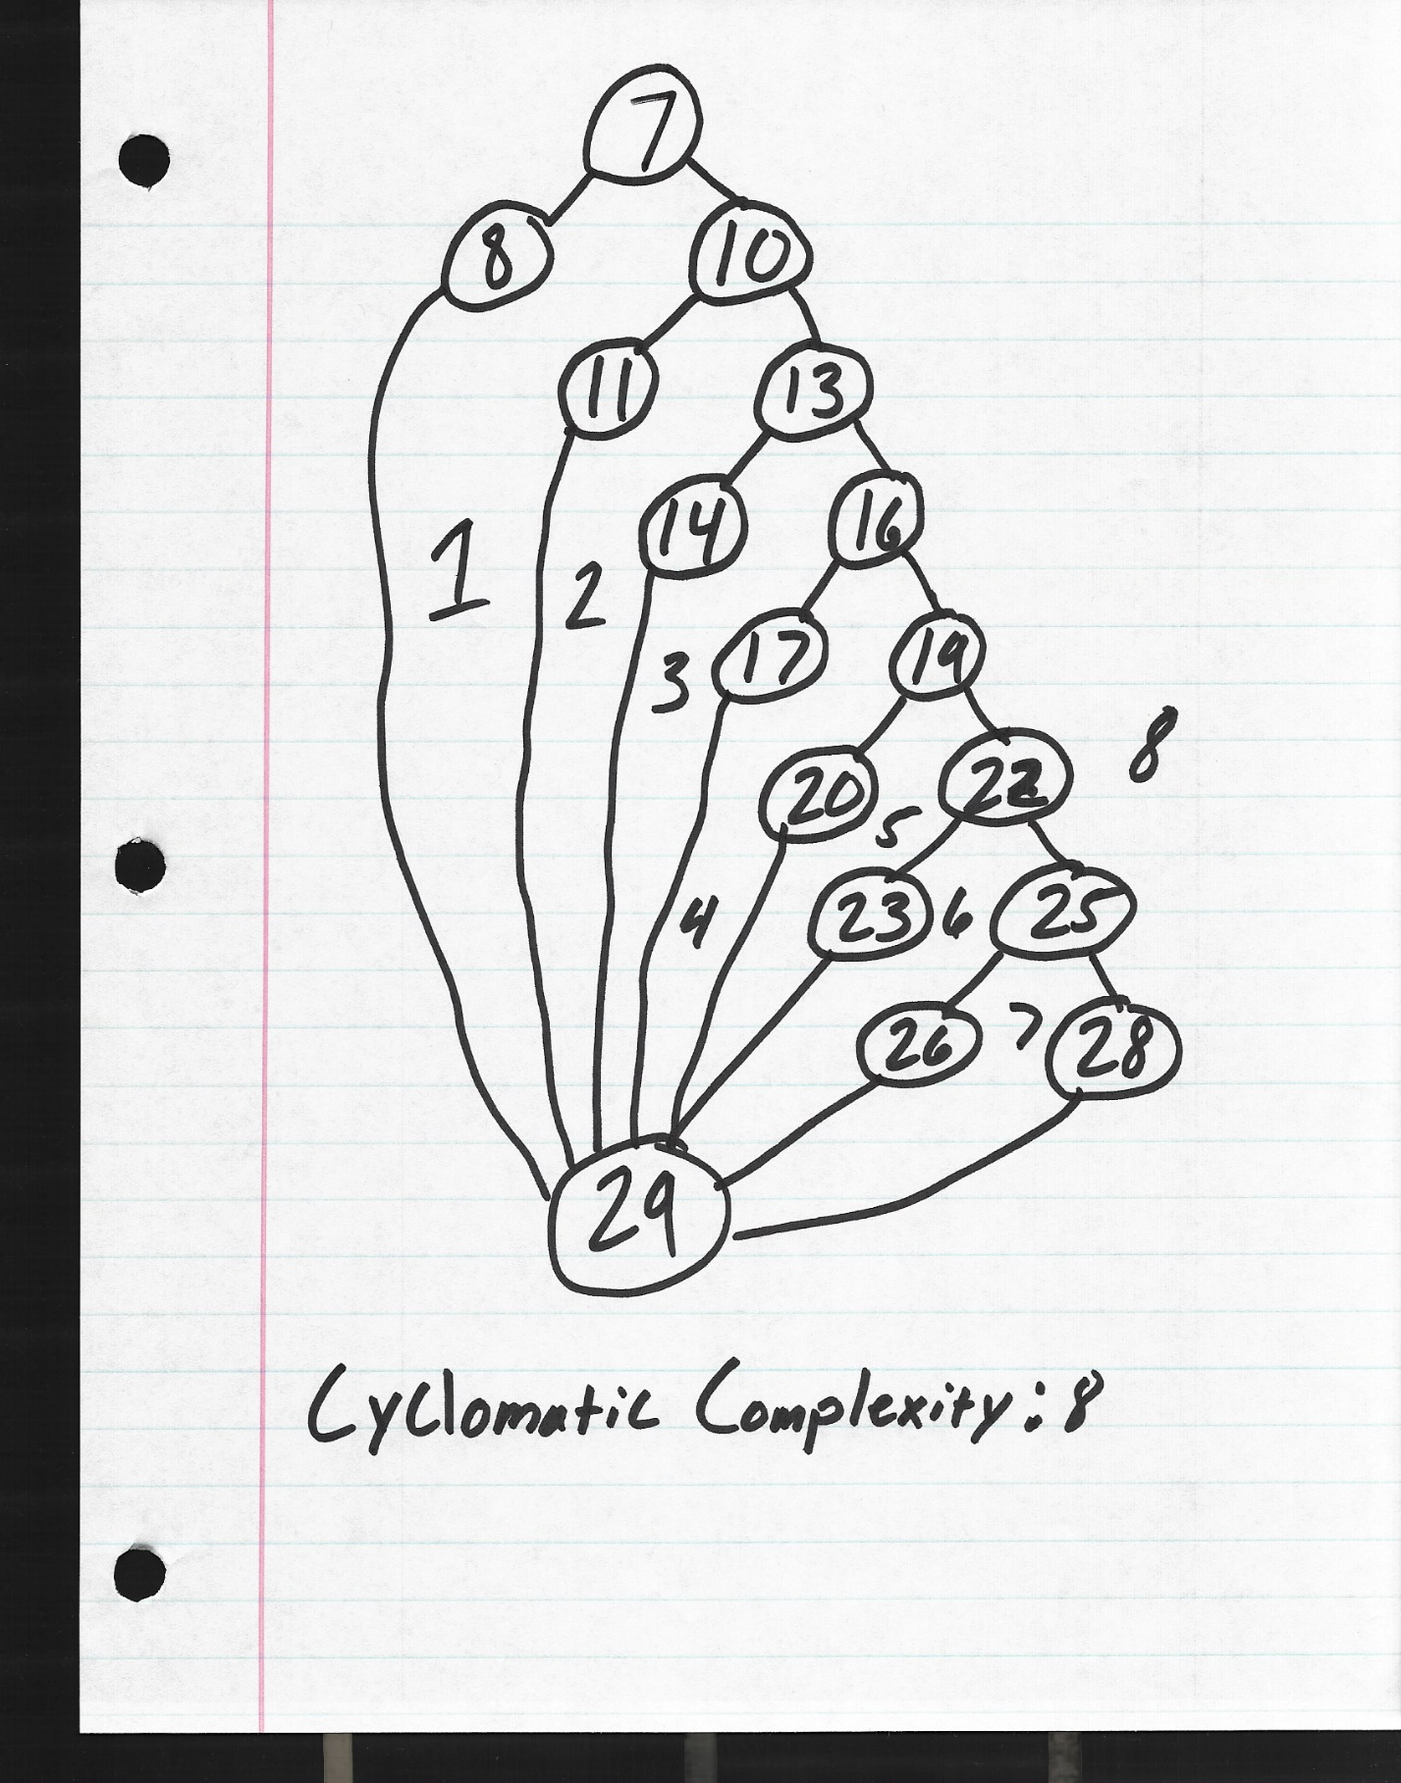

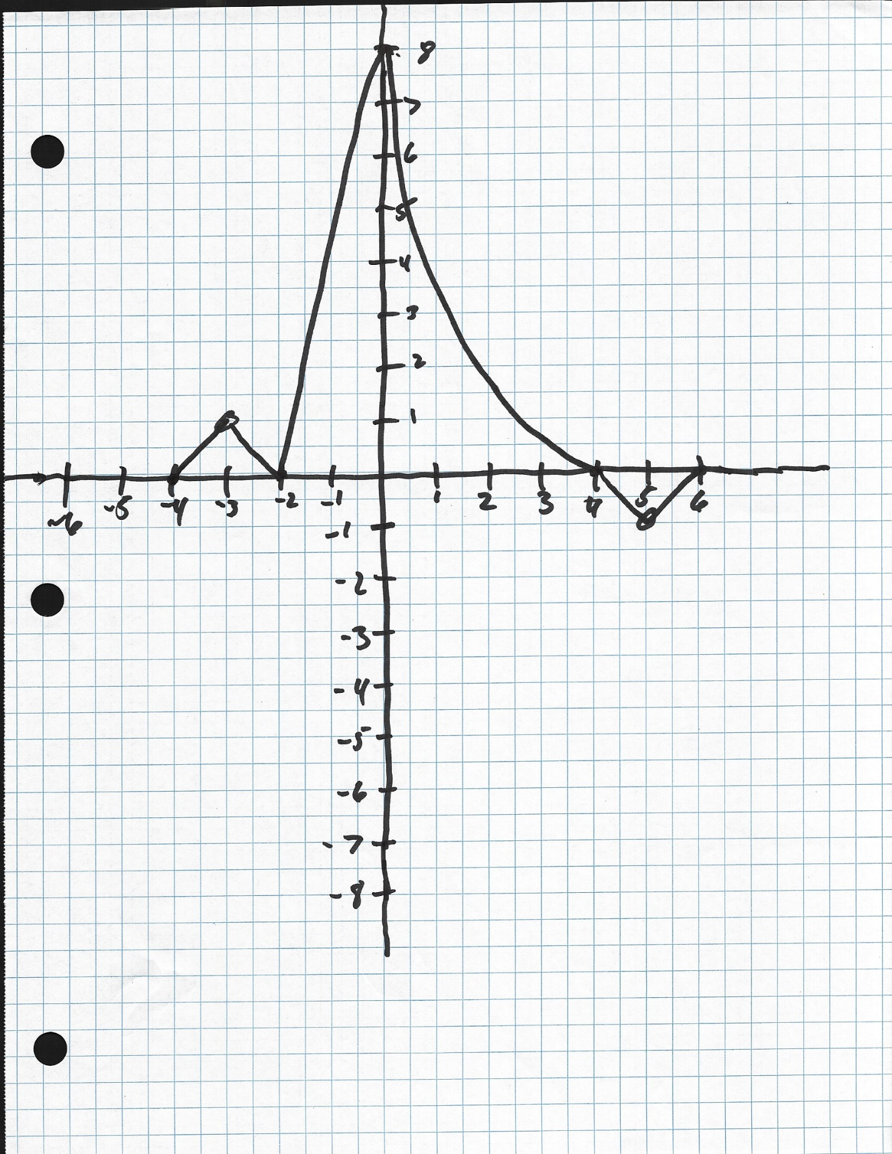

|  |  |  |  |
| --- | --- | --- | --- |
| **Test Case Number** | **Inputs** | **Exp Out** | **Basis Path Tested** |
| **x** | **y** |
| 1 | -4.01 | 0.00 | 7-8-29 |
| 2 | -3.01 | 0.99 | 7-10-11-29 |
| 3 | -2.00 | 0.00 | 7-10-13-14-29 |
| 4 | -0.01 | 7.96 | 7-10-13-16-17-29 |
| 5 | 3.99 | 31.90 | 7-10-13-16-19-20-29 |
| 6 | 5.00 | -1.00 | 7-10-13-16-19-22-23-29 |
| 7 | 5.99 | -0.01 | 7-10-13-16-19-22-25-26-29 |
| 8 | 6.00 | 0.00 | 7-10-13-16-19-22-25-28-29 |
| 9 | -4.00 | 0.00 | - |
| 10 | -3.00 | 1.00 | - |
| 11 | -1.99 | 0.04 | - |
| 12 | 0.00 | 8.00 | - |
| 13 | 4.00 | 0.00 | - |
| 14 | 5.01 | -0.99 | - |
| 15 | 6.00 | 0.00 | - |
| 16 | -3.50 | 0.50 | - |
| 17 | -2.50 | 0.50 | - |
| 18 | -1.00 | 4.00 | - |
| 19 | 2.00 | 16.00 | - |
| 20 | 4.50 | -0.50 | - |
| 21 | 5.50 | -0.50 | - |
| 22 | -5.00 | 0.00 | - |
| 23 | 8.00 | 0.00 | - |

**Full Statement and Decision coverage achieved**

**Test cases support description**